# Automatic detection of regional new particle formation

In order to detect regional new particle formation (RNPF) the monitored air masses have to stay constant over the period of interested growth range. Thus, only RNPF events that occur during conditions of stable air masses are possible to detect. Detection is based on monitoring time evolvement of aerosol size distribution.

Detection includes steps:

1. Aerosol data is cleaned from noise (single exceptionally high values) by applying 3 point median filter.
2. The data is smoothed by 2-dimentional smoothing algorithm (do we have to give exact values of smoothing window?, 5 points in particle size dimension and 9 points in time dimension (90min), moving median) (fig HJ1)
3. Aerosol size distribution up about 20nm is considered
4. Concentration of 20nm particles is subtracted from the smaller sizes
5. Regions of positive values are marked with 1 and other with 0 (Fig HJ2, panel A). Part of data marked with 1 is called region of interest (ROI).
6. 25% percentile is calculated of all data values in all ROIs and is set as a threshold value
7. New ROIs are calculated by looking for data values that are above the threshold. Each old ROI is stepped through separately and time range considered is starting moment of old ROI plus 12h
8. The new ROIs are new particle formation events. If the event occurred during light hours (after sunrise and before sunset) an event can be considered as RNPF. Figure HJ3 shows the automatically detected event regions.

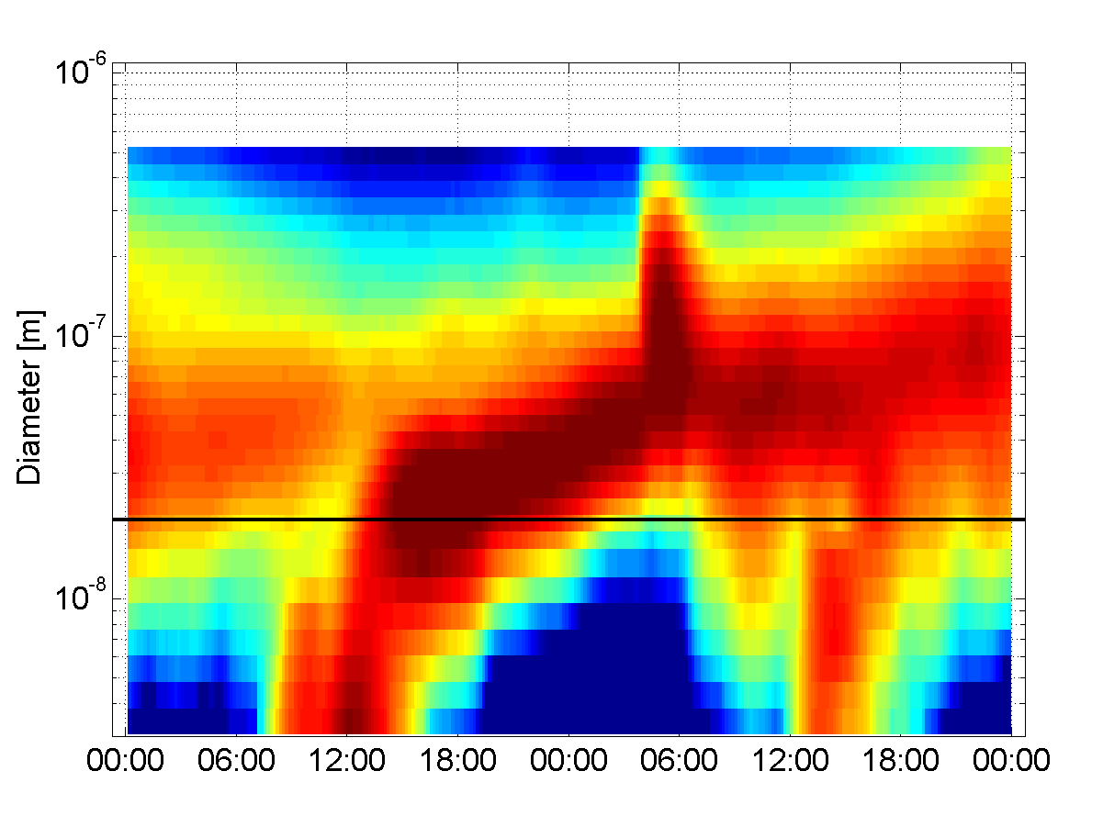

Fig HJ1. Smoothed aerosol size distribution for 15-14 Apr 2004 Black line denotes 20nm limit.

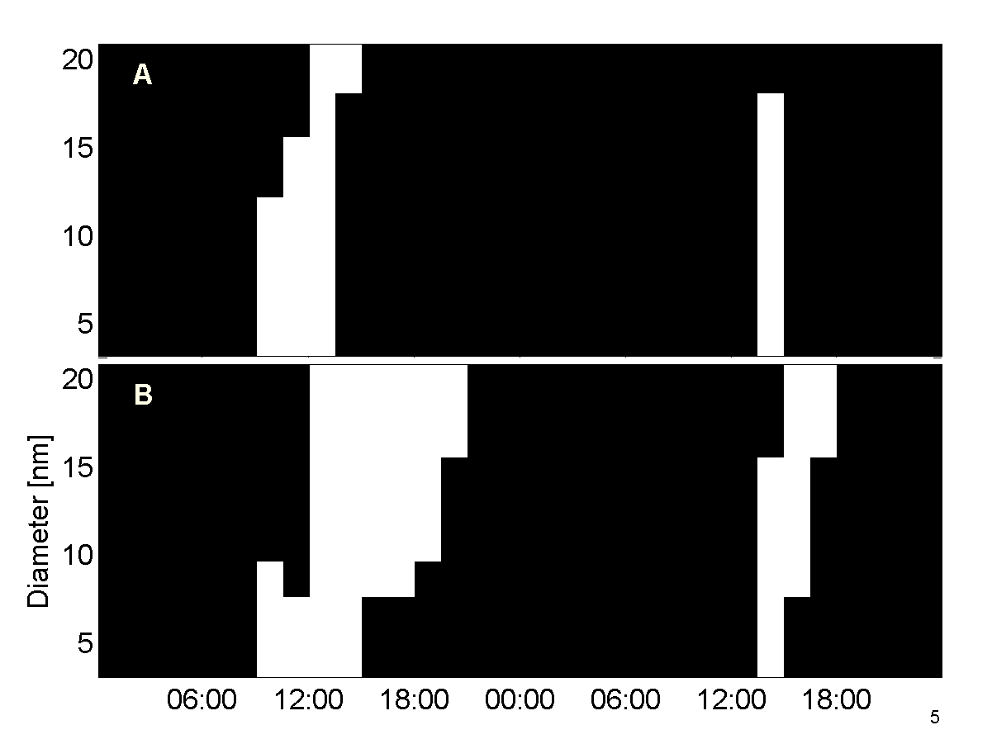

FigHJ2. Regions of interests (ROI) for RNPF detection. Panel A – highlighted regions where particle concentration is higher than concentration of 20nm particles. Panel B – highlighted regions where particle concentration are higher than the threshold value (25% percentile value of ROIs in panel A).

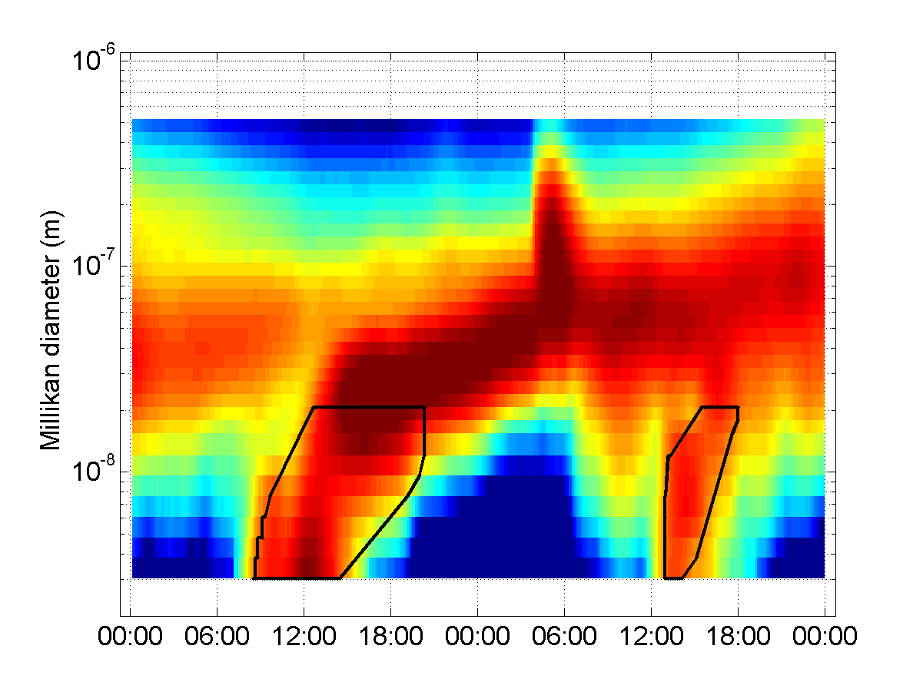

Fig HJ3. Automatically detected RNPF events, first starting at 15-Apr-2004 08:28:44 and the second at 16-Apr-2004 12:58:45

# Automatic growth rate analysis for RNPF events

Once RNPF event regions are identified one can automatically determine the growth rate using only the data that belongs the RNPF events. Growth rate determination includes following steps:

1. stepping through each detected RNPF event separately
2. selecting two sequential size ranges (S1, S2) of particle concentration time series
3. normalize data dividing by sum of each size selection
4. calculate forth power of the data (this is used to increase the weight of data at the center of the particle mode but not to search for a peak or maxima)
5. determine the time shift (dT) between the two time series that minimizes root mean square difference of normalized concentrations
6. growth rate will be GR=(S2-S1)/dT.
7. this is repeated to each size range of the data

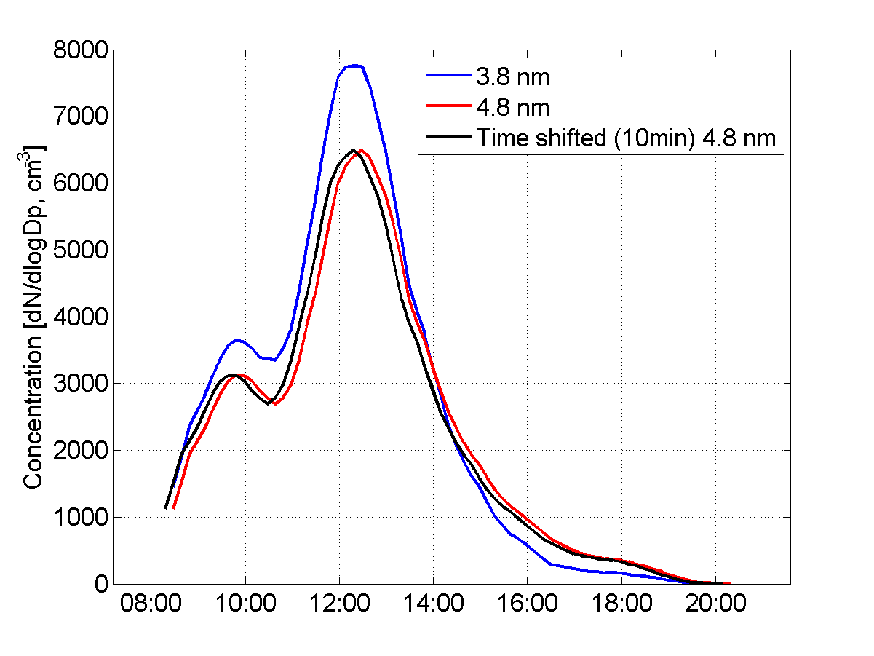

Fig HJ4. Time series of particles for the event starting at 15-Apr-2004 08:28:44. Time shift was 10 min.

Figure HJ5 summarizes the automatic event detection and analysis. During two day period two RNPF events have been identified and growth rate determined for each size range of the given data. In figure the point of maximum concentration is marked with white edged dots from where line ending with black dot is calculated growth of the mode using determined growth rate. Median growth rates for the two events are 4.7 and 11.3 nm/h, respectively.

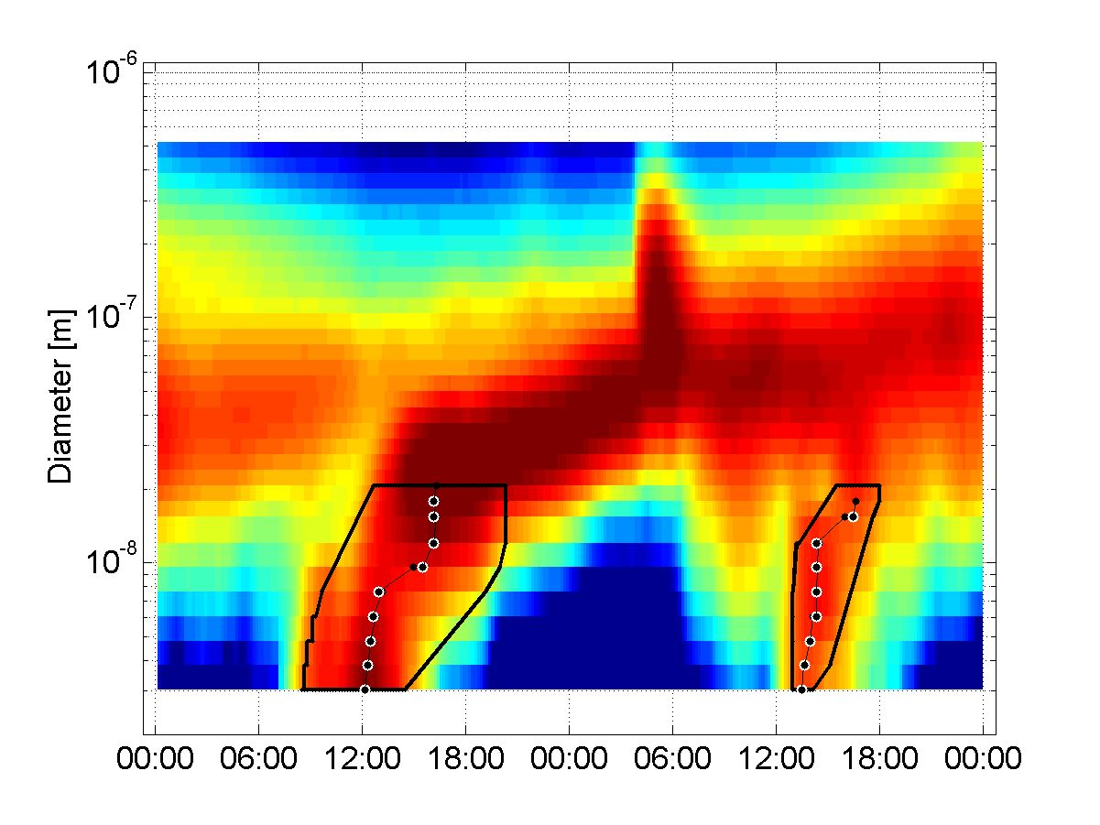

Fig HJ5. Aerosol size distribution for 15-14 Apr 2004 with two automatically identified RNPF events. White edged dots are maximum concentration point for each size segment, black lines with black dot are calculated trajectory of growing mode to the next particle size using determined growth rates.